` `

|  |  |  |
| --- | --- | --- |
| Macintosh HD:Users:barbarahessova:Downloads:logo_ahproduction.png | Macintosh HD:Users:peterharum:Documents:RTVS-loga-8.jpg | Macintosh HD:Users:barbarahessova:Documents:dokumenty :PROJEKTY:COMEBACK:3.titulky dialogovka a preklady:loga:nove loga do titulkov Comeback:VSMU:logo_vsmu_poz.pdf |

**PRODUCTION AND DISTRIBUTION OF THIS FILM WAS SUPPORTED BY**

Macintosh HD:Users:peterharum:Downloads:en PC:logo AVF color EN  PC:logo AVF color EN PC.eps



AH production Ltd., Slovak Television and Academy of Performing Arts in Bratislava

PRESENT A DOCUMENTARY FILM

**COMEBACK**

Recidivists in a vicious circle.

Macintosh HD:Users:peterharum:Library:Containers:com.apple.mail:Data:Library:Mail Downloads:03A06722-46EA-41E2-B0B6-2CC008AF5BE4:Karlovy Vary loga:loga-KVIFF:KVIFF-lg-pantone.eps

|  |  |  |  |
| --- | --- | --- | --- |
| PRESS CONTACT – at IFF Karlovy Vary:  Barbara Harumová Hessová  hessova@ah.sk  + 421 908 786 843  FESTIVALS:  [festivals@ah.sk](mailto:festivals@ah.sk)  [hessova@ah.sk](mailto:hessova@ah.sk) | PRODUCER’S CONTACT:  Barbara Harumová Hessová  hessova@ah.sk | www.ah.sk  + 421 908 786 843  AH production, s.r.o.  Irkutská 14/D | 851 10 Bratislava | Slovakia | PR in Slovakia  Eva Rebollo  rebollo@asfk.sk  +421 905 984 410 | SLOVAK DISTRIBUTOR:  Asociácia slovenských filmových klubov (ASFK)  Brnianska 33,  81104 Bratislava  Tel.: +421 2 54652018, +421 2 54652019  E-mail: asfk@asfk.sk |

**COMEBACK**

**TECHNICAL INFORMATION:**

Original Language: Slovak

Subtitles: English

Running Time: 85 Minutes

Film Format: DCP, COLOUR

Frame Rate: 25 fps

Sound Format: 5.1

Status: World Premiere - IFF KARLOVY VARY 2014 (Documentary Film - Competition)

Screenings: 6.7.2014 18:30 Čas Cinema

7.7.2014 14:00 Drahomíra Cinema

**LOGLINE:**

Coming out of the prison two recidivists evaluate their past and look into the future outside of jail. Once out, they fight with the reality of life, trying to survive before it is too late. Can somebody find a solution?

**SYNOPSIS:**

Time in one of Slovakia’s most guarded prisons, where most of the prisoners return regularly, passes very slowly. Two recidivists evaluate their past and look into the future as the time of their release approaches. How does the whole process look and what awaits Zlatko and Miro outside of jail after many years? Once out, they are empty-handed with no education and a criminal record. A complicated family background and no friends acting as positive models giving them a chance to integrate into normal life. Baffled, they observe what’s new on the outside - women, cars, fashion, smart phones – everything has changed, but they remain the same. Will they be able to start from scratch and is it safe for the society? How much can a mother of a jailbird handle? Is the judicial system fair enough? The story of repeat criminals’ reintegration and being trapped in a vicious circle.

**DIRECTOR’S STATEMENT:**

From a social and societal point of view, recidivism is the biggest problem of the prison system. A vast majority of those who get out of prison commit another crime. In the most maximum-security prison in Ilava it’s no different, with 90% of inmates who get out returning to the institution. Being let out of prison after serving a term of 10 years or more is an enormous change. Several thousand days of a long-term, daily prison routine suddenly ends and the inmate is once again free. The return to society is very difficult – prison and freedom are two absolutely different worlds. Those ten or twenty years, usually the productive years of a person’s life, have vanished. They leave the prison and essentially have nothing. Things that seem normal and ordinary to people on the outside present a big problem to the ex-convict. They don’t have anywhere to live or work, don’t have clothes or food, and after getting out have no idea even where the bus stop is.

At the very beginning of shooting, the Institute for Punishment and Imprisonment in Ilava was very forthcoming. The director at the time personally asked the pedagogues under his charge to identify for us prisoners who were appropriate for filming - those who were slotted to go free and were willing to talk about themselves on camera. That was our only condition. We wanted to follow their steps down the path to freedom. In the end, this condition was met by only two prisoners, Zlatko and Miroslav, whose fateful moments we were able to experience together with them. One of them had been there for 17 years already and the other was a “first-time offender” with a ten-year sentence. Behind the extraordinary trust shown to us by the prison management was their satisfaction with the results of a previous cooperative EU project on reintegration called Equal – Let’s Recover Discarded Opportunities. In terms of filming *Comeback*, this meant a relatively large degree of freedom in an otherwise very strict regime. The screenwriter Juraj Šlauka and I were able to enter a cell in the blue clothes as new prisoners and initiate communication with five previously identified prisoners through a card game. This way we got to know them very quickly and came to the inmates with an already planned concept, which mainly dealt with the influence of the environment on changes in sexual orientation. This concept proved to be naive and so during the card game we talked about other topics that were currently relevant in prison. We played, talked and did research as we searched for a theme. And the process was repeated twice at a later date. Everything was filmed just to be sure. The material we gathered from these conversations, however, took on meaning when the reporter Miroslava Ábelova entered into the story. We then repeated conversations in the prison with her as well in such a way that it was possible to connect them to previously filmed conversations with the inmates. Shooting such a process brings with it lots of interesting information and connections beyond the mise-en-scène. Certain situations just simply cannot be filmed – the camera cannot be everywhere. In the end, the various circumstances during the days of shooting determined the final appearance of the film edited by Marek Kráľovský.

**PRODUCER’S STATEMENT:**

We began work on this film as a group of students in 2008. Shooting continued throughout 2009 and beyond at Ilava prison, one of the most heavily guarded in Slovakia, as well as outside of the prison near Trenčín and in Bratislava, the capital of Slovakia. At the beginning the conditions and opportunities for shooting the film inside of the prison were very strict, but good thanks to the personal intervention of the institution’s management, which was interested in a true-to-life portrayal of the environment and prison issues, and thanks to a guarantee from the management of the Academy of Performing Arts at that time, as well as quality work by the entire film crew. During shooting, several prisoners were moved to other institutions and several were let out during a problematic period when we were unable to shoot. Because of the difficulty of getting into the prison and the irreplaceable individual situations that arose, we shot with three cameras simultaneously even on 16mm film during the first years of work. That is why we have three main DOPs ( Jaroslav Vaľko, Ivo Miko and Mário Ondriš) and several assistants who helped us when they were not available and we had to make some shooting immediately.

There were many obstacles that came up during shooting. Among them were three changes in the Ilava prison management and a changes in the Corps of Prison and Court Guards (GRZVJS). As a result of political decisions and changes at the Ministry of Justice, which governs the GRZVJS, and the new management of the prison, shooting was prohibited. In the middle of shooting, the existence of our project was threatened. After the changes, the process of organizing and planning one day of filming at the institution became even more difficult for administrative reasons and because of the prison’s new approach resulting from mistrust on the part of the new management. I had to explain the new managements that what we aimed to do was show the topic from a serious point of view in as truthful a way as possible on film. Nonetheless, after several applications and visits we built up a good relationship and mutual trust with the new prison management as well. One of the more complicated moments was filming the court proceedings of one of our protagonists. The material shot at the proceedings will also serve as teaching material for law students. We also shot footage in the psychiatric hospital in Trenčín, where permission to film was initially refused several times. During the entire filming process, about 20 complete days of planned shooting were cancelled because of force majeur or the decisions of bureaucrats or other responsible persons. My frustration was, however, often mitigated by the unbelievable experiences and stories we came across during filming, or that we lived through ourselves, and I realized then how relatively small our own problems were. Without the personal conviction of people who went to a maximum effort to help us it would have been impossible. I would like to publicly thank everyone on the title credits of the film, as well as those who appeared in it and who were willing to share their fates with us.

Without initial support from the Academy of Performing Arts in Bratislava, where the director and I did our doctoral studies, and without the financial support of the Audiovisual fund, the Slovak Ministry of Culture and Slovak television entering into final phase, I would not have been able to finance necessary shooting expenses and post-production of this movie. We have come to this point after six years of hard work and it is thanks to the sacrifice and enthusiasm of every member of our team, crew and others who assisted us in completing the film. Here I would like to thank them very much.

In my opinion, there is more than one interesting topic in this movie. It portrays different layers, including: questions of guilt; warped sexuality; complicated family relationships; an absurd judicial system and the lack of a systematic socialization process; personal despair; and the inability to reintegrate into society. I hope that people will find our film interesting.

**FILM TEAM:**

PRODUCER:

**Barbara Harumová Hessová** graduated in film and multimedia production and distribution at the Film and Television Faculty of the Academy of Performing Arts in Bratislava, where she received the Rector’s Prize and subsequently undertook her doctoral studies. She and the screenwriter of the script Before Take-Off were awarded the main prize at the Midpoint international workshop. The successful short film Arsy Versy, produced by Barbara, has won many over 40 international film festival awards. She has worked for several production houses on documentary and feature films, as well as TV serials. She has also worked for the Audiovisual Fund as a grant application administrator and later as a member of various Fund expert committees. In 2007, she founded AH production where she develops and produces feature-length documentaries and feature films (So Far, So Near, Comeback, Judge Me and Prove Me, Sister Zdenka, Stanko, Flooded, Parlika..), as well as cooperation on TV programs and serials. She was a participant in the Emerging Producers program organized by the Jihlava IFF. She teaches at the Department of Production and Distribution and at the same time is a Vice-Dean for International Relations at the Film and Television Faculty of the Academy of Performing Arts (VŠMU).

DIRECTOR:

**Miro Remo** is originally from the industrial town of Ladce (Slovakia), where he attended elementary school. He barely finished his secondary school (gymnazium) in Považská Bystrica. As soon as he was accepted into the documentary film-directing program at the Academy of Performing Arts, he left his mechatronics studies to study in the film atelier of Vlado Balco at the Academy, where he currently continues to work. Miro is the holder of more than 40 awards from international film festivals. Miro’s most successful film so far is a portrait of his uncle and grandmother called *Arsy-Versy*. In terms of number of awards received, it is the most successful Slovak film ever. Currently, he is working on several original films and television programming. *Comeback* is his feature-length cinema debut.

SCRIPTWRITER:

**Juro Šlauka** comes from Ladce, Slovakia. He studied dramaturgy and screenwriting at the Academy of Performing Arts in Bratislava.

EDITOR:

**Marek Kráľovský** graduated from the Department of Editing at the Academy of Performing Arts in Bratislava, Slovakia in 2002. Soon after finishing his studies he was asked by Hollywood-based directors, Agnieszka Holland and Kasia Adamik, to edit a Slovak clone of Robin Hood – *Janosik: A True Story*. Afterwards Kráľovský continued in his work and edited several award-winning documentaries, animation and feature films. He became a close collaborator of Austrian documentarist Georg Misch, English director Sophie Fiennes and Middle East based Azza El-Hassan. His editing contribution to *Arsy-Versy* by Miro Remo helped the film obtain more than 40 prizes. In addition to his lucid storytelling, one of his skills is using models of human psychological behaviour to enrich the films he works on.

DOP‘s:

**Ivo Miko** comes from Sabinov, Slovakia. After graduating from the Faculty of Physical Education and Sports in Bratislava he decided to dedicate himself to a film career and began to study at the Film and TV Faculty of the Academy of Performing Arts in Bratislava. Within the faculty, he studied at the Department of Camera and Photography, where he also completed his doctoral studies. During his studies he worked as a DOP on several films and received several awards. He graduated with a movie called *Otec* that won the top award for best film at the 39th Film Festival Sehsuchte in Potsdam, Germany. He was a DOP on the film *I am the miner, who is more*, which won several student awards as well as a prize for cinematography at the Slovak competition of cinematographers Kamera 2013. He worked as the second cameraman on a feature film titled *Exhibition*, which won an award at Febio Fest in Prague, and he also won the main prize at Emir Kusturica’s festival in Kustendorfe. He currently works as a freelance cameraman.

**Mário Ondriš** was born in Piešťany, Slovakia. From 2002 until 2007, he studied at the Academy of Performing Arts in Bratislava. His filmography consists of: the full-length feature film *Lóve*; the documentaries *Cold Joint* and *Pornomantik*; and the sitcom *Zita na krku*.

**Jaroslav Vaľko**

Like his colleagues, Jaroslav also studied at the Academy of Performing Arts. He comes from and works in Prešov, where he films video clips and sometimes runs to Bratislava to work as a cameraman on documentary films.

SOUND:

**Lukáš Kasprzyk** – Graduated in sound composition studies at the Academy of Performing Arts. As a student he was already making his first two feature-length films *BratislavaFILM* and *Lóve*. Currently, he is working on several film, television and Internet projects.

ORIGINAL MUSIC BY:

**David Kollar** is a young generation artist, guitarist and film music composer with a unique musical vision that absorbs and reflects all manner of music while retaining an enviable individualism and high quality craftsmanship. His work spans from creative music to very powerful and deep music. By age 30 he had released six albums and created music for more than 20 films and theatre performances. His latest album THE SON (Hevhetia, this music was also used in *Comeback*) was featured among the top albums of the year in several countries (USA, France, Czech Republic and Slovakia). The album has a huge following abroad because of the originality of both the guitar playing and musical composition.

**FULL PRODUCTION CREDITS:**

Production and distribution of this film was supported by

Macintosh HD:Users:peterharum:Downloads:en PC:logo AVF color EN  PC:logo AVF color EN PC.eps

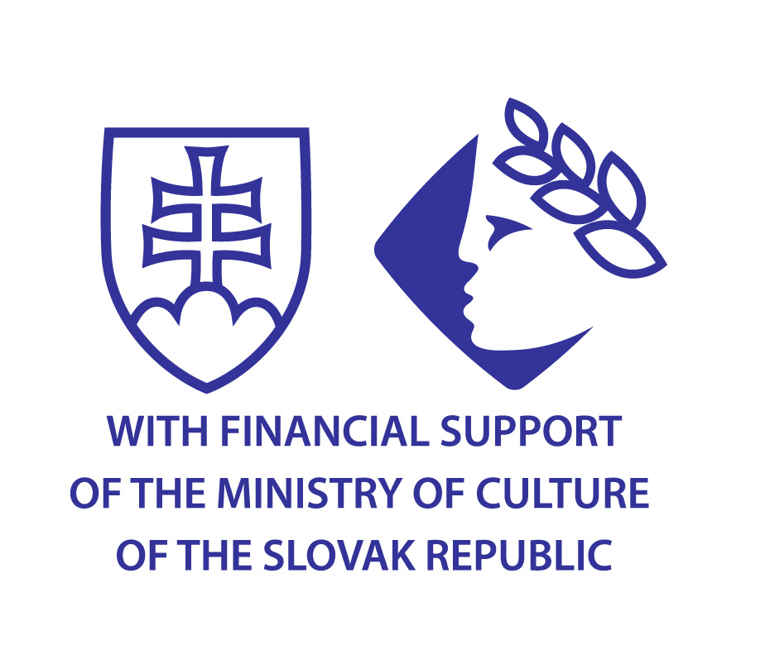

AH production

Slovak Television

and Academy of Performing Arts

present a

dokumentary film

**COMEBACK**

**Some opinions of people performing in the film might be misinterpretations not based on truth.**

**Screenplay:**

Miro Remo

**Screenplay:**

Juraj Šlauka

**Dramaturge:**

Juraj Šlauka

**Editor:**

Marek Kráľovský

**DOP:**

Jaroslav Vaľko,

**DOP:**

Ivo Miko

**DOP 16 mm:**

Mário Ondriš

**Sound:**

Lukáš Kasprzyk

**Music composed by:**

David Kollar

**Director:**

Miro Remo

**Producer:**

Barbara Harumová Hessová

**Supervision:**

Vlado Balco

**Special Thanks:**

Mirke, Vierke, Mirovi, a Zlatkovi and all those who appeared in the film for their cooperation.

Filmová a televízna fakulta Vysokej školy múzických umení

Andrea Biskupičová

Leo Štefankovič

Ján Oparty

Generálne riaditeľstvo Zboru väzenskej a justičnej stráže

Ústav na výkon trestu odňatia slobody a Ústav na výkon väzby v Ilave

plk. Mgr. Ladislav Resek - riaditeľ ústavu (2004 – 2010)

plk. PhDr. Mária Kreslová – generálna riaditeľka (2007 - 2010)

mjr. Mgr. Róbert Mudronček - riaditeľ ústavu v roku 2010  a generálny riaditeľ ( 2010 - 2012)

pplk. Mgr. Adrián Baláž

mjr. Mgr. Ladislav Paško

mjr. PhDr. Jozef Klučka

mjr. Mgr. Alexander Balucha

mjr. JUDr. Daniel Blaško

kpt. Mgr. Peter Janto

mjr. Mgr. Jozef Kurus

kpt. Mgr. František Pavlík

npor. Dušan Mateička

npor. Peter Huňačka

Všeobecná ambulancia pre odsúdených a obvinených

MUDr. Arnošt Bak

Janka Šedíková

Ústredie práce sociálnych vecí a rodiny, Detašované pracovisko Bratislava 5

PhDr. Jana Lavová

PhDr. Margita Putzová

Fakultá nemocnica Trenčín, Psychiatrická klinika

doc. Mudr Jozef Hašto, PhDr.

MUDr. Branislav Moťovský

PhDr. Ivana Ilavská

Rímskokatolícky kostol Všesvätých – kostol trinitárov, Ilava

Peter Jurčík

Krajský súd v Trenčíne

**Thanks:**

vydavateľstvo Hevhetia

Dispečing laboratórií Barrandov

Kino X Stupava

JAMFILM 1999

AudioMaster

Ľuboš Elias

Anton Serholec

Štefan Švec

Zlatica Stroffeková

Katarína Ebersová

Miroslava Zemková

Ľuboš Machaj

Veronika Mareková

Zuzana Jankovičová

Marek Kučera

Ivo Brachtl

Marcela Guličová

Mário Havránek

Dominika Tomková

Peter Riapoš

Katarína Štuková

Eči Skurka

Ľubica Olšovská

Michal Tvarožek

Andrea Šprochová

Eugen Korda

Peter Petrus

Miloš Čikovský

Štefan Lelovič

Tobiáš Potočný

Rasťo Tupý

Pavol Šmatlák

Ružena Micháleková

Andrej Kolenčík

Peter Harum

Wilhelm Hess

Etela Hessová

Rastislav Meliška

Martin Muráni

Mária Mareková

Anton Machala

Ján Slovák

Michal Bielik

Miro Remo st.,

Viera Remová

Dušan Ruman

Alena Rumanová

Dagmar Faturíková

Radovan Bielený

Tomáš Dvornický

Silvia Turčíková

Soňa Tomášových

Radoslav Kutaš

Mária Moravčíková

Martin Šmatlák

Dagmar Franzenová

**Crew:**

**Camera operators and assistants:**

Mário Kičák,

Lukáš Teren,

Juraj Ištvánik,

Miro Remo

**Boom Operators:**

Lukáš Kasprzyk

Boris Varga

Michal Džadoň

Mišo Prokeš

Boris Vereš

Martin Králik

Ján Hetmer

Miloš Hanzély

Tomáš Gregor

Sašo Bori

Miro Remo

**Post Production Sound Services By**

Soundline

**Dolby Sound Mixing By**

Dimas digital master studio

**Sound Mixing:**

Bohumil Martinák

**Special Effects:**

Marek Ježo

Ľubomír Ježo

Tomáš Lomnický

Oliver Popellár

Bluefaces

**Grading**

Bronislava Brtáňová

**English Subtitles:**

Julia Sherwood

**Dramaturge of English Subtitles:**

Anna Kareninová

**Dramaturge RTVS**

Alexandra Gunišová Ševčíková

**Head of production RTVS**

Tibor Horváth

**Production RTVS**

Ivana Zlatňanská

**Head Of Documentary Department in RTVS**

Miroslava Tomaníková

**Executive Producer and Production**

Barbara Harumová Hessová

Music from the album The Son is from the music publishing house Hevhetia

Music:  David Kollar

Vocals: Lenka Dusilova,

Catalogue No: HV 0072-2-331

Song „Aj tak sme stále frajeri“  is from the Opus Publishing House,

Authors:  Július Kinček a Peter Nagy

Interprets: Peter Nagy a Indigo

Catalogue No: 9313 2154

Music improvisation

Vladimír Varšavík

Production and distribution of this film was supported by

Macintosh HD:Users:peterharum:Downloads:en PC:logo AVF color EN  PC:logo AVF color EN PC.eps



**©** AH production, s.r.o.  RTVS,  VŠMU 2014

www.comebackmovie.sk

www.facebook.com/comebackmovie

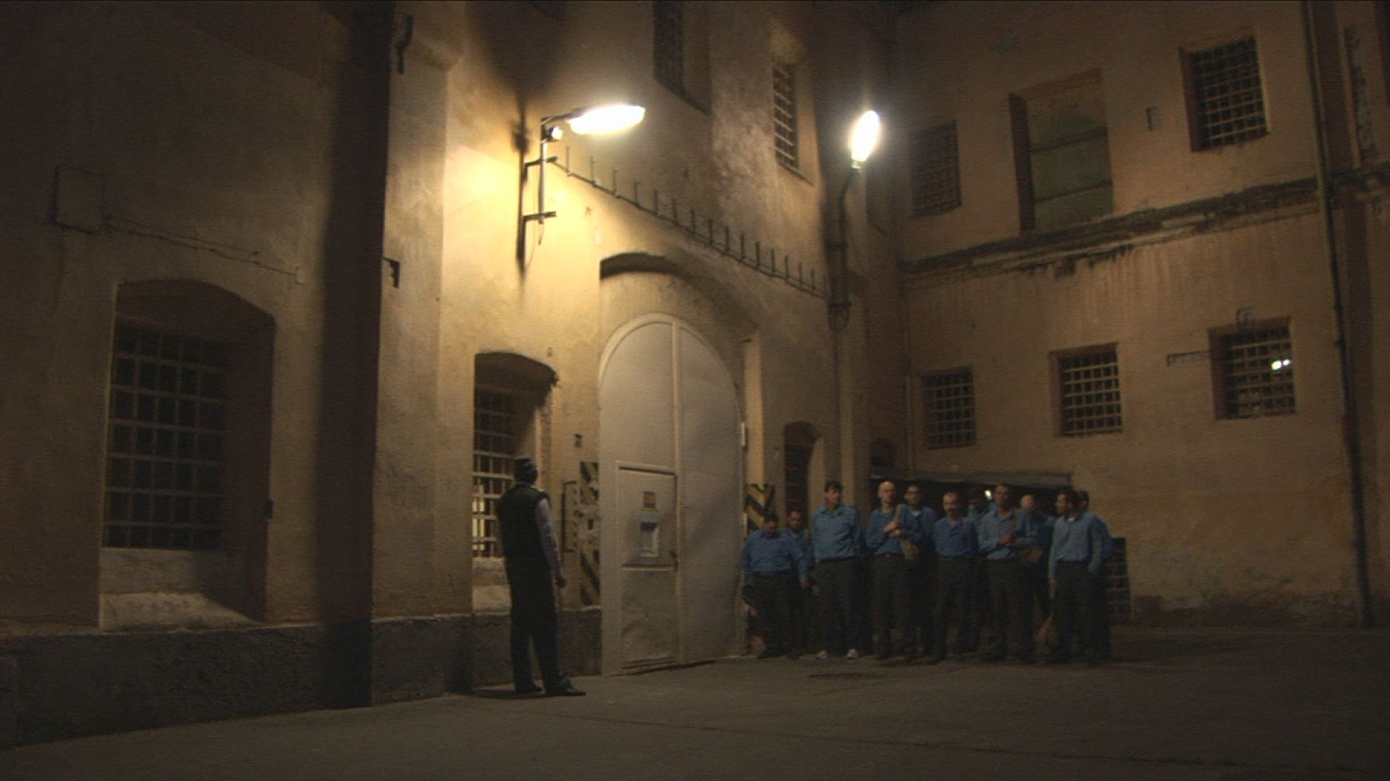

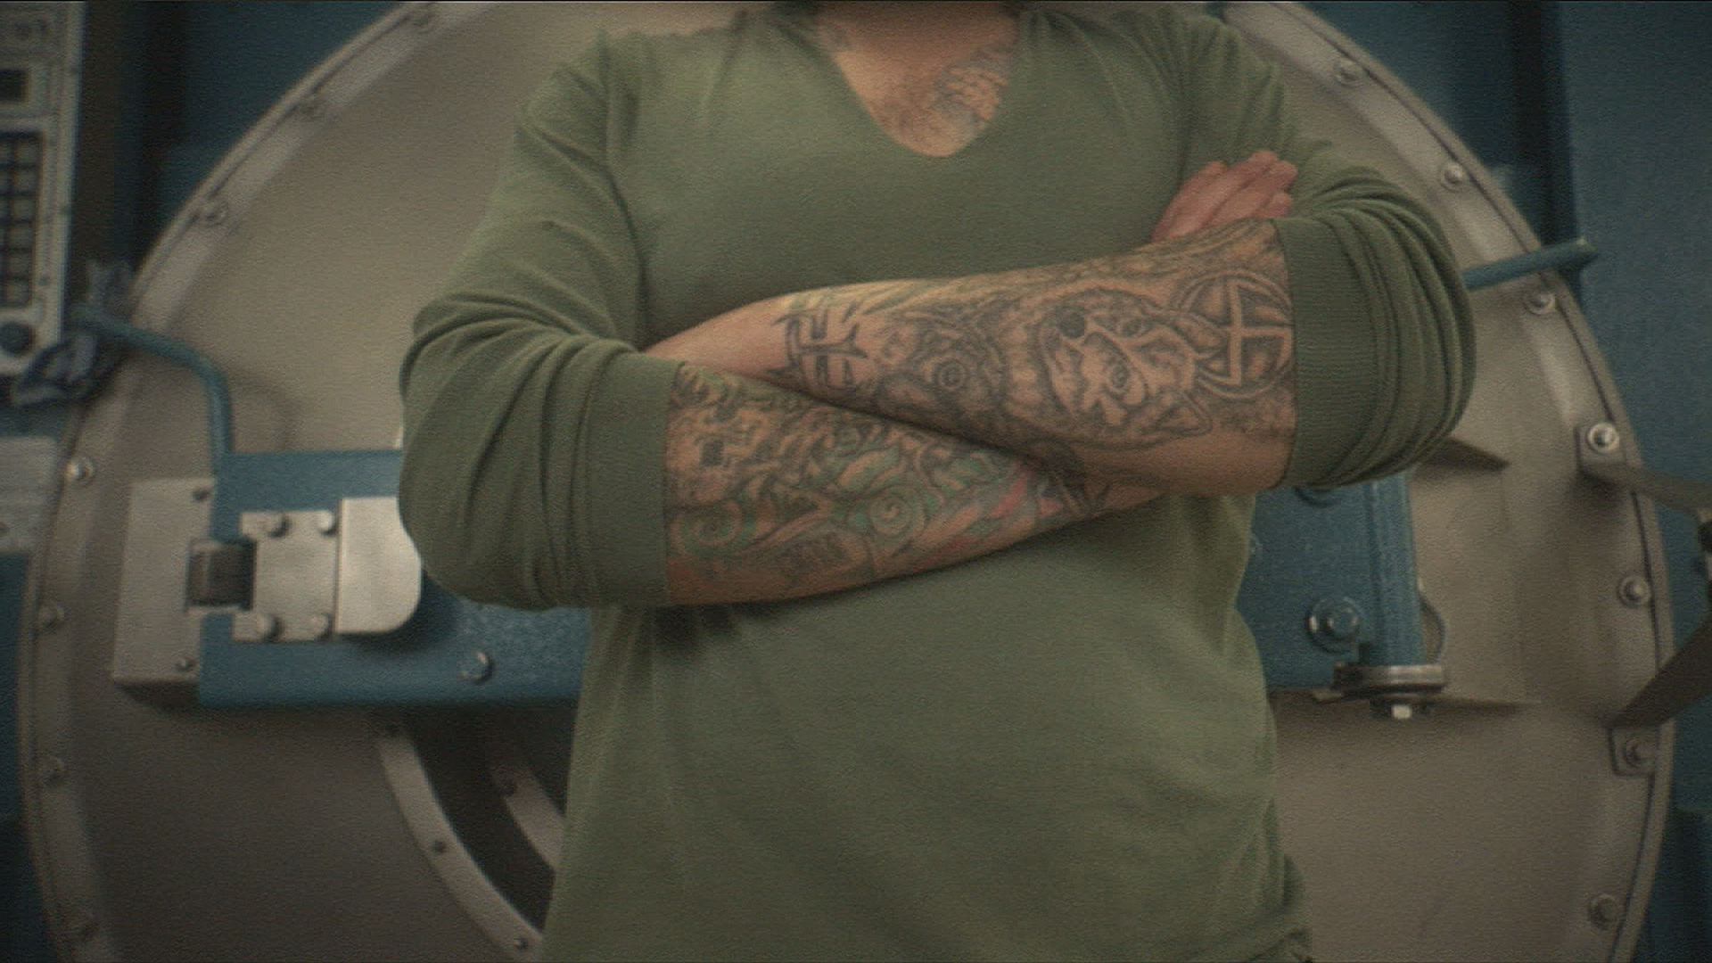

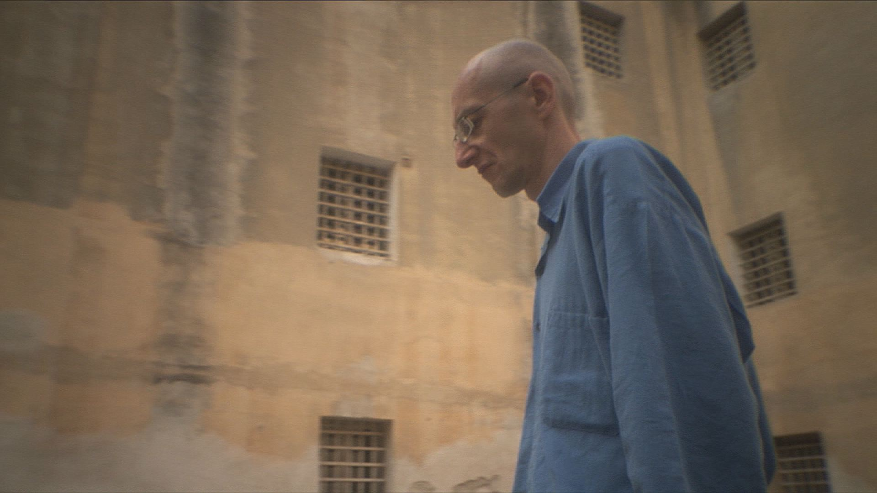

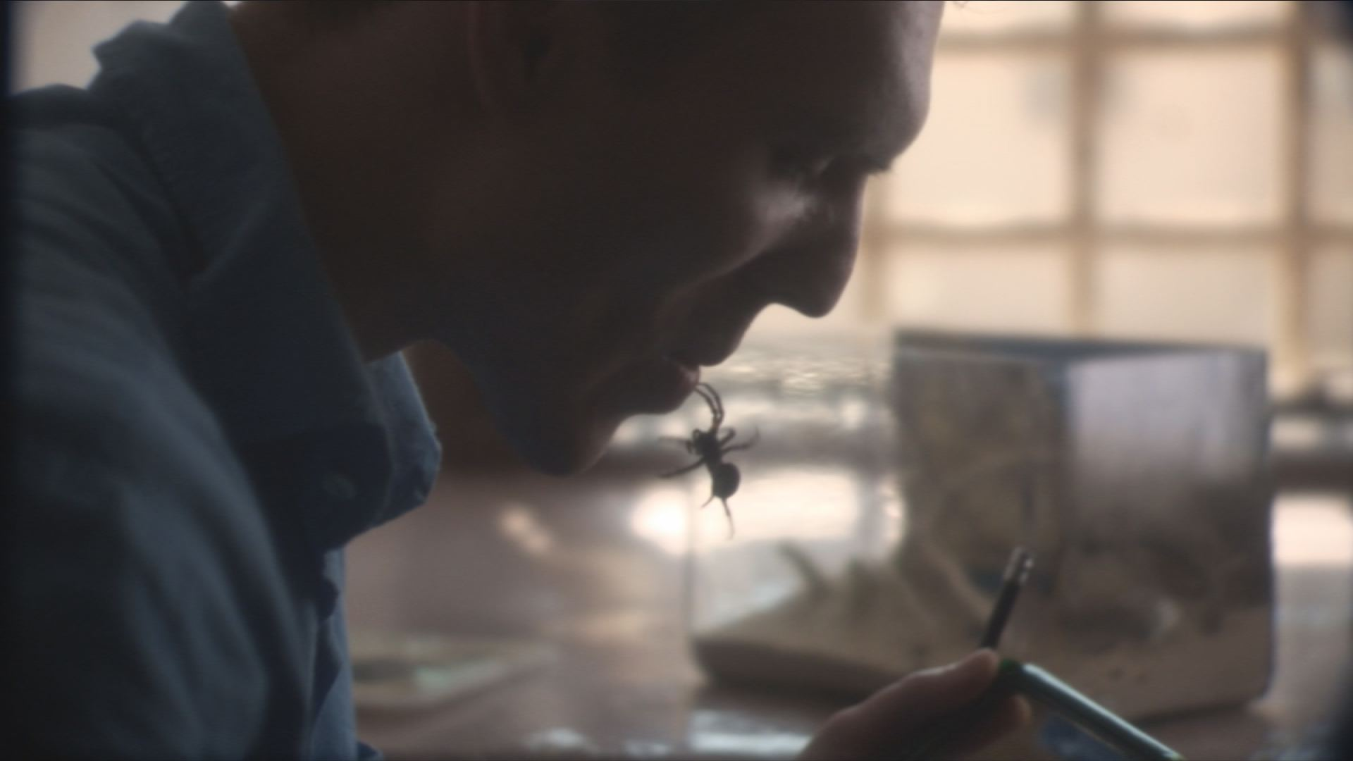

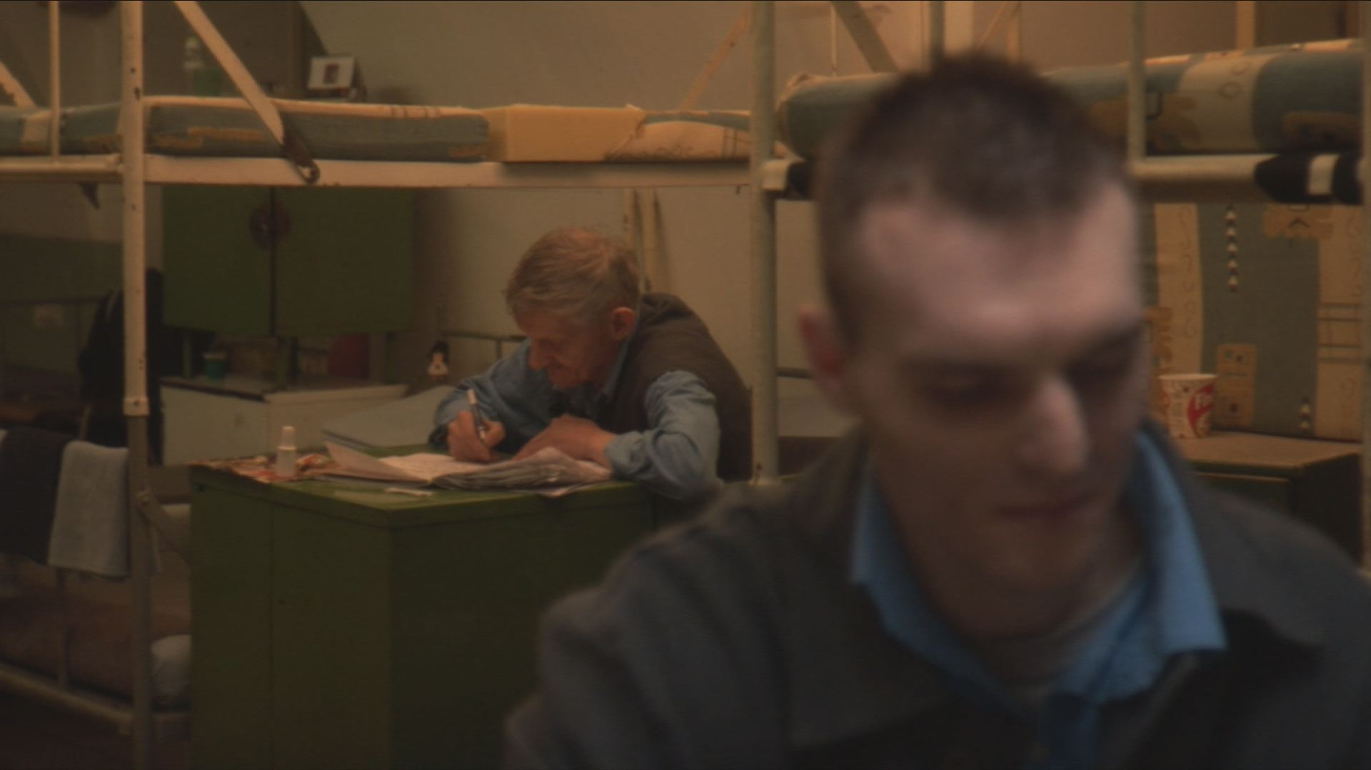

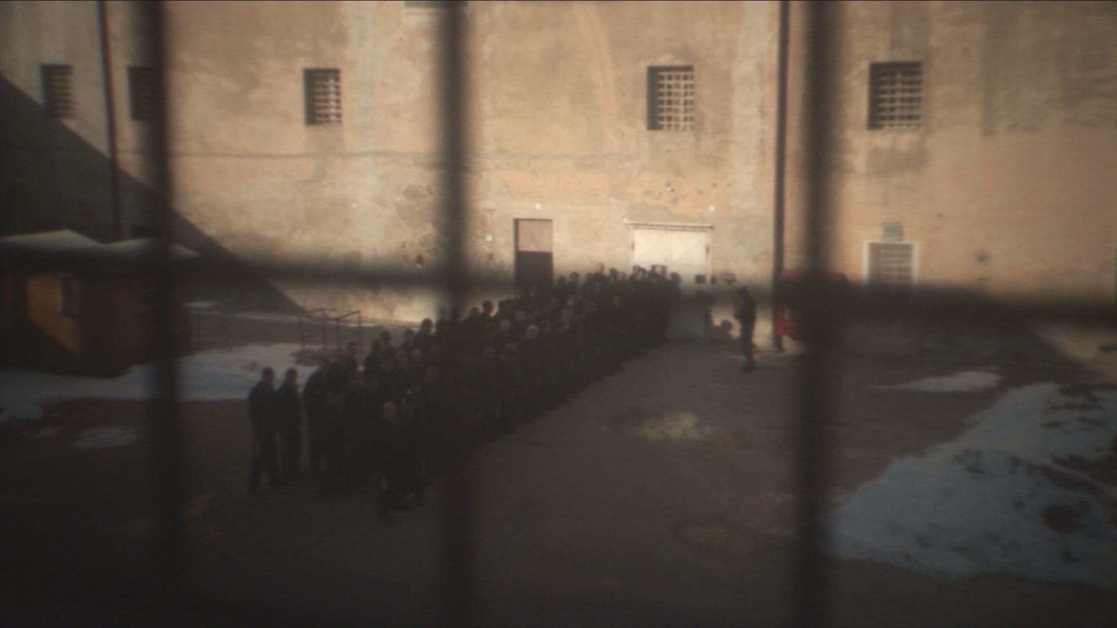

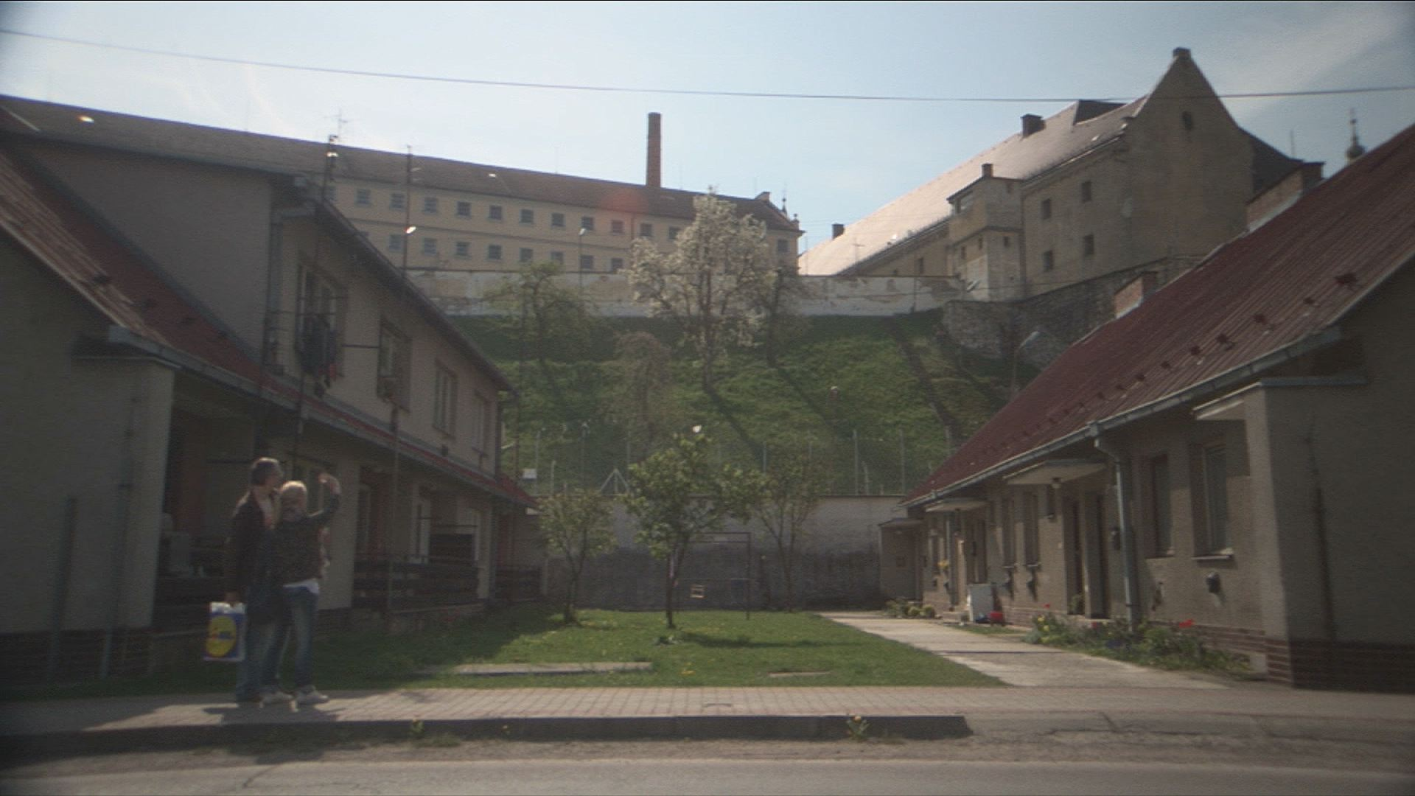

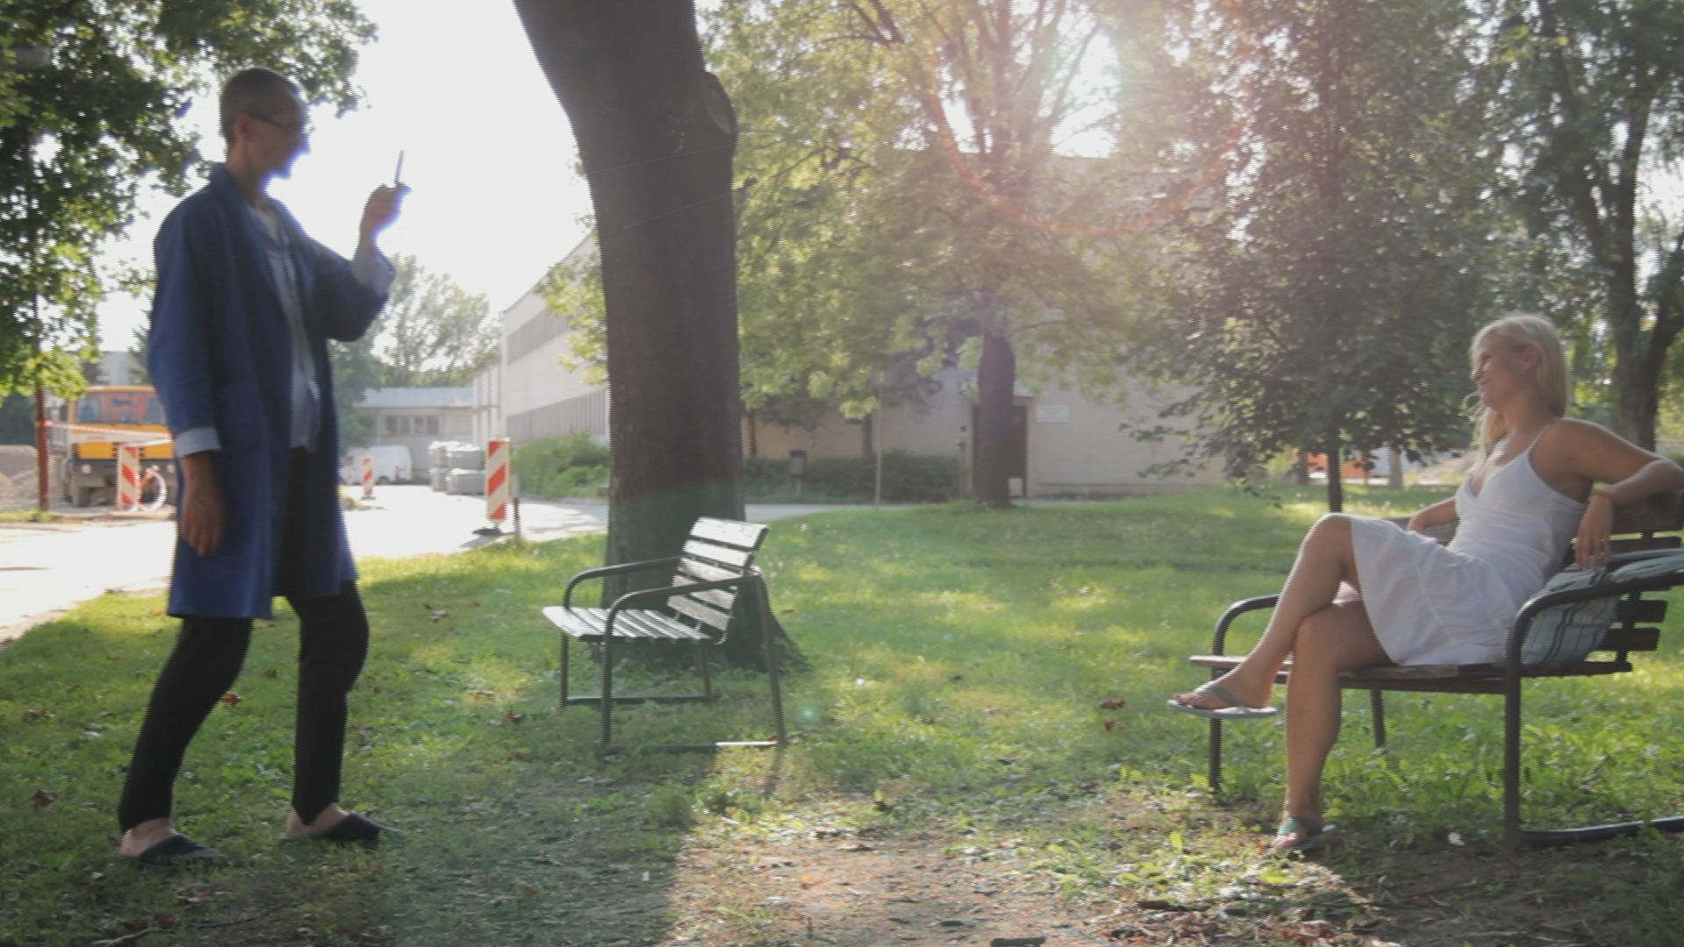

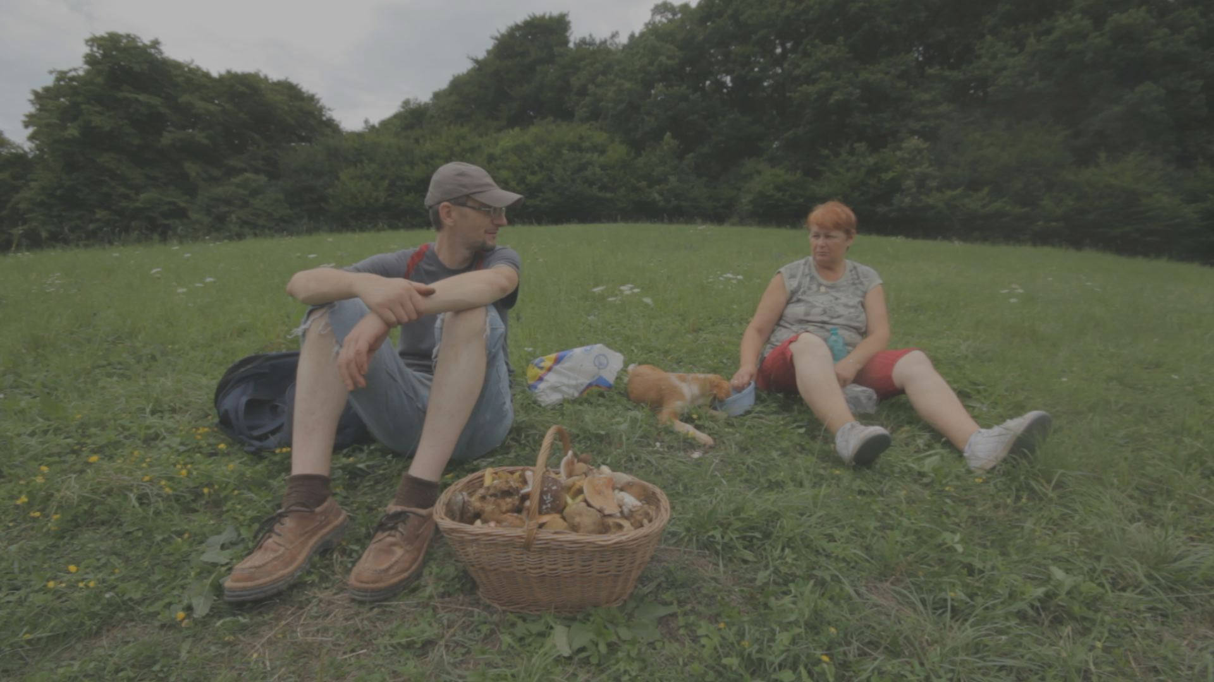

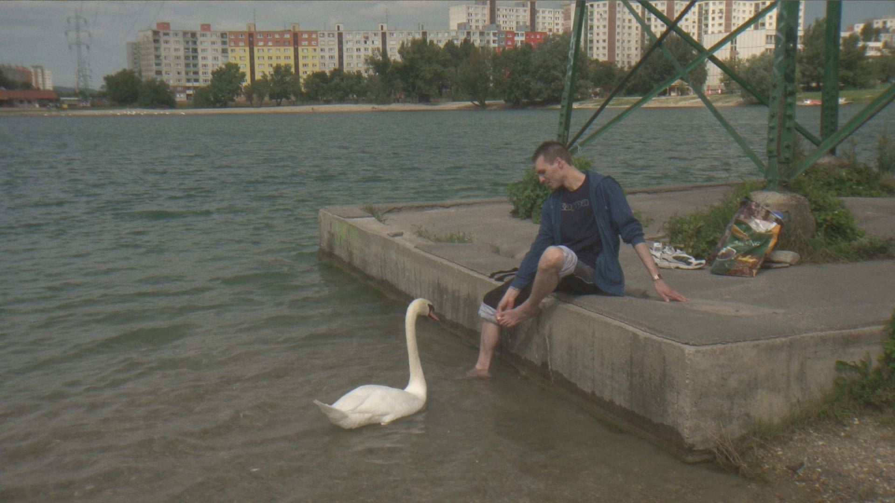

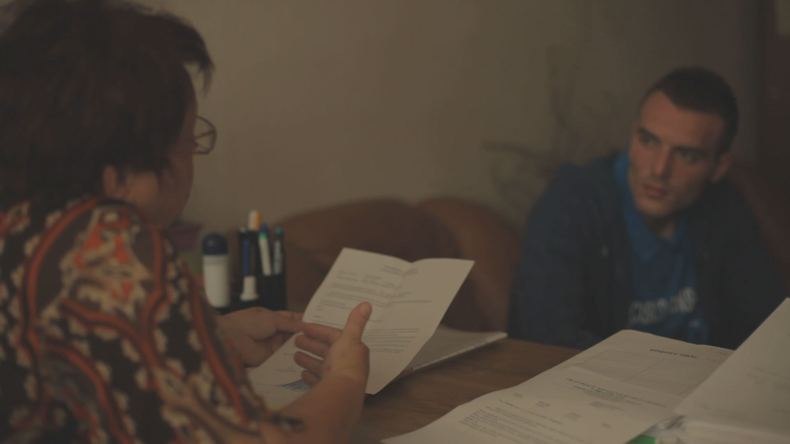

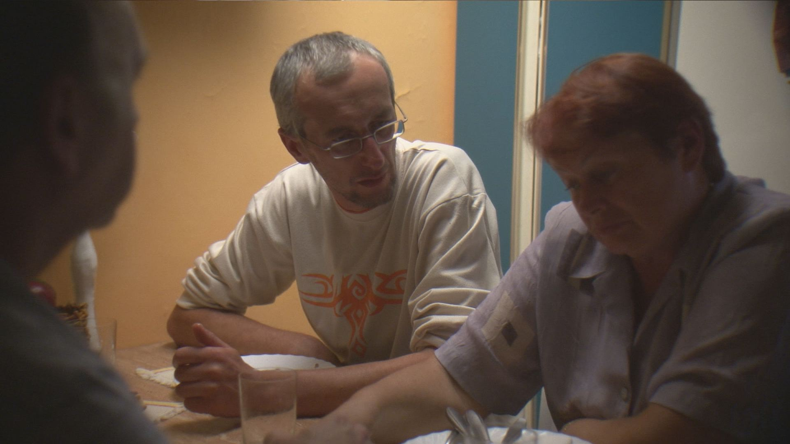

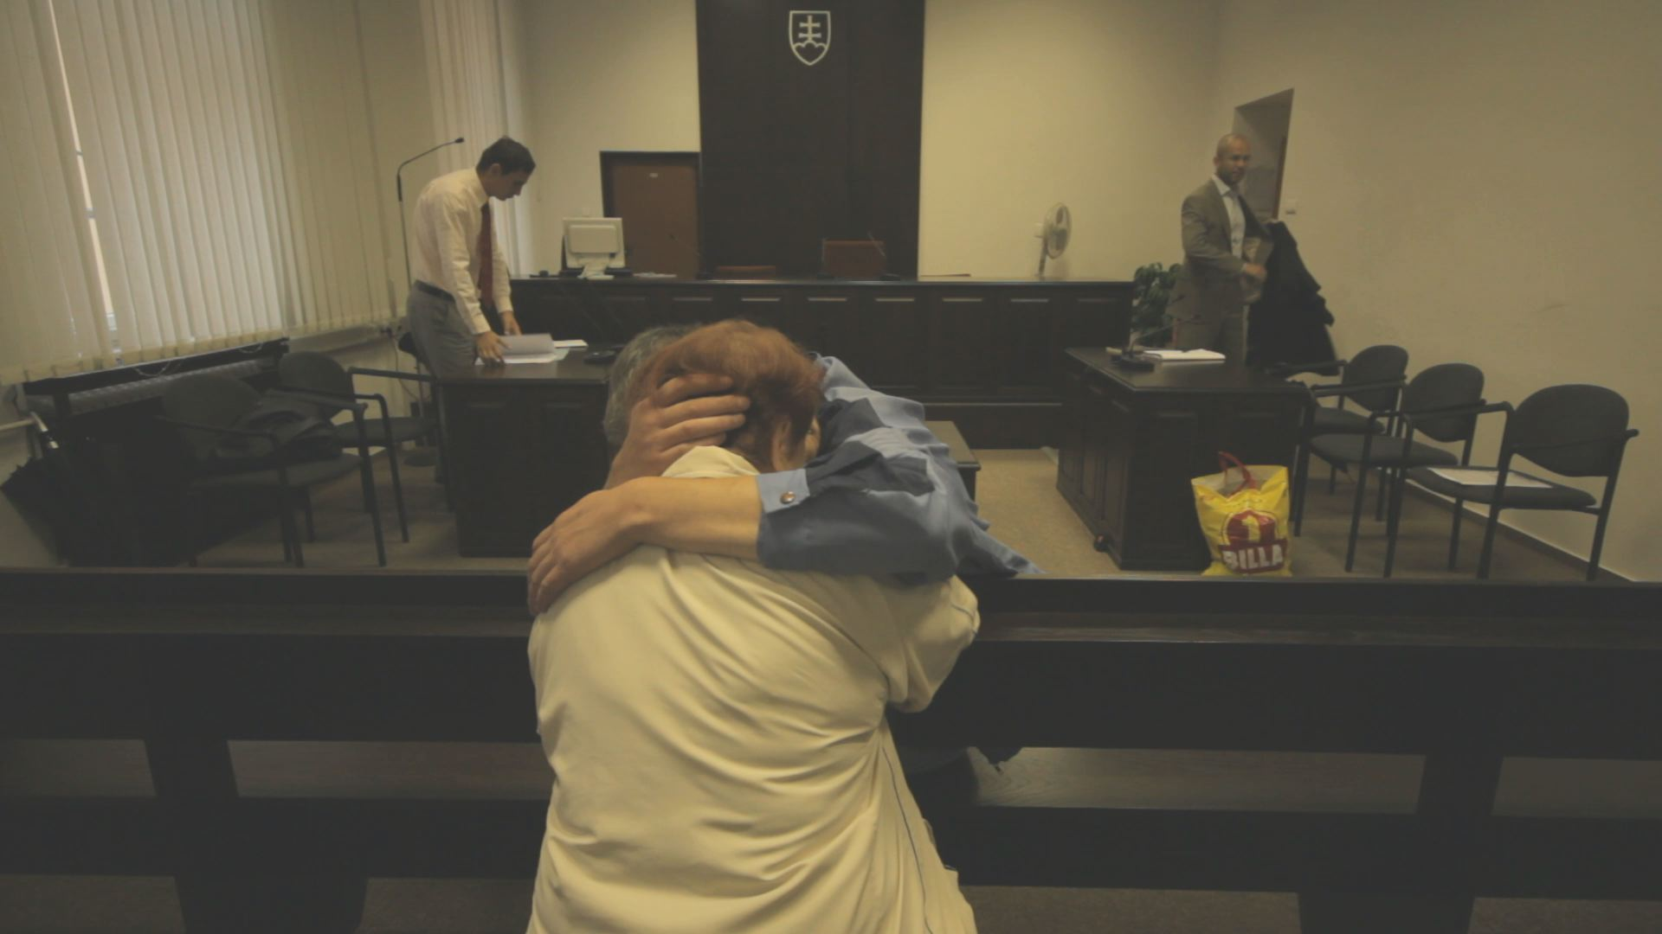

**© AH production, s.r.o. 2014**